Contents

<For Marketing> 2
1. Customer feedback 2
2. How does this kit work? 3
3. What does “In a Phase I clinical trial, the specificity of this kit was 99.6%, and the overall diagnostic accuracy was 98.1%”mean？ 4
<Clinical Practice> 5
1. Does a positive result equal to infection of the novel coronavirus? 5
2. Does a positive result of antibodies of the novel coronavirus can confirm the diagnosis of COVID-19? 5
3. How to explain a positive result without any related symptoms? 5
4. Will any symptoms of a "cold" affect the test results? 6
5. Does a positive test results plus COVID-19 related symptoms (such as fever, fatigue, cough, temperature over 37.3℃, etc.) indicate a confirmation of COVID-19? 6
6. If you need to take a nucleic acid test of COVID-19, what should you do? 7
7. How to deal with the wastes after a self-test at home？ 7
8. Does a negative result indicate the non-infection of the novel coronavirus? 7
< Lab Procedures > 8
1. What are the precautions for the COVID-19 antibody test? 8
2. What is the difference between direct blood drop and diluted blood drop? 8
3. Transportation and Storage 9
4. Is this kit sterile? Is there any possibility of getting infection due to improper operation? 9

FAQs about COVID-19 IgM/IgG Test kit (Bestnovo)

<For Marketing>

Customer feedback
- This kit is co-developed by Bestnovo and Prof. Dr. Junbo Ge. Dr. Junbo Ge is MD, FACC, FESC, FSCAI Academician, Chinese Academy of Sciences, Professor of Medicine/Cardiology, Director, Department of Cardiology, Zhongshan Hospital, Fudan University, Chairman, Shanghai Institute of Cardiovascular Diseases
- This kit has obtained the registration certification of Jiangsu Testing and Inspection Institute for Medical Device.
- This kit has been sent to National Medical Products Administration for emergency approval.
- In a Phase I clinical trial, the specificity of this kit was 99.6%, and the overall diagnostic accuracy was 98.1%.
- This kit has been applied in following institutions：Jiangsu Provincial Center for Disease Control and Prevention; Shanghai Public Health Clinical Center; Zhongshan Hospital, Fudan University; Taizhou People's Hospital, Jiangsu, China.

How does this kit work?
In this kit, colloidal gold immunochromatography is used to detect IgM and IgG antibodies of the novel coronavirus of COVID-19. Mouse anti-human IgM and mouse anti-human IgG is labeled by Colloidal gold and the nitrocellulose membrane is coated with the novel coronavirus (the antigen). Colloidal gold immunochromatography is used to detect antibodies to the novel coronavirus in human serum, plasma, or whole blood. After the test, the COVID-19 IgM/IgG antibody was detected by observing the colloidal gold color reaction of the T line and the C line. The results can be observed by naked eyes.
- Positive Result: If both the quality control line (C) and the detection line (T) appear red or purplish-red lines, the COVID-19 IgM/IgG antibody is detected. The result is positive.
- Negative Result：If the quality control line (C line) appears a red or purplish-red line, while the test line (T line) is invisible, there's no COVID-19 IgM/IgG antibody in the tested samples, or the concentration is lower than the lower limit of the test agent.
- Invalid Result: If there is no line at the position of quality control line (line C) in the observation window, this test is invalid, the test should be repeated.

What does “In a Phase I clinical trial, the specificity of this kit was 99.6%, and the overall diagnostic accuracy was 98.1%”mean？
Specificity refers to the probability of false-negative in the diagnosis of a disease. The specificity of this kit is 99.6%; in other words, there is almost no false-negative; the accuracy of our testing kit is very high with the accuracy rate of 98.1%.

<Clinical Practice>

Does a positive result equal to infection of the novel coronavirus?
It is the antibody, instead of the antigen of the novel coronavirus, that is tested in this kit; thus, a positive result could not confirm the diagnosis of COVID-19. The diagnosis should be obtained in combination with the epidemiological history, clinical symptoms, physical signs, biochemistry tests, lung CT scan and viral nucleic acid test results

Does a positive result of antibodies of the novel coronavirus can confirm the diagnosis of COVID-19?
A Positive result of COVID-19 antibodies suggests that the subject may have been infected by the novel coronavirus recently. Thus, a re-test is suggested. If the result of a re-test is still positive, it is recommended to go to nearby "COVID-19 designated hospital" for a further confirmation test.

How to explain a positive result without any related symptoms?
If the subject has no COVID-19 -related symptoms, but the antibody test result is positive, it may be for the following reasons:
- The COVID-19 infection may be at a latent period, the COVID-19 specific antibody level has increased, but the patient has no clinical symptoms.
- This is a kind of asymptomatic COVID-19; such patients have similar situations.
- Some other factors may lead to false-positive antibody test results, such as tumors, hepatitis virus infection, or autoimmune diseases. COVID-19 designated hospital is recommended for further confirmation.
- Contamination of the sample may also lead to false-positive results.
Therefore, it is recommended to take a retest in such circumstance. If the result is still positive, please go to a COVID-19 designated for further confirmation.

Will any symptoms of a "cold" affect the test results?
No. The detection of the COVID-19 specific antibody is not affected by other influenza viruses or respiratory viruses. Therefore, this test could be taken when having symptoms of a "cold "or "flu".

Does a positive test results plus COVID-19 related symptoms (such as fever, fatigue, cough, temperature over 37.3℃, etc.) indicate a confirmation of COVID-19?
If COVID-19 related symptoms exist, and antibody test results are positive, it may be COVID-19, but the diagnosis cannot be confirmed. If the result is still positive after repeating, please go to a COVID-19 designated for further confirmation.

If you need to take a nucleic acid test of COVID-19, what should you do?
If you need to take a nucleic acid test of COVID-19, it is recommended that you go to a nearby “COVID-19 designated hospital" to ensure the accuracy of the results

How to deal with the wastes after a self-test at home？
After a self-test, the blood sampling needle, colloidal gold test strip, and other wastes should be put into a sealed pocket, and then be sprayed with 84 disinfectant or 75% alcohol for disinfection, then discard.

Does a negative result indicate the non-infection of the novel coronavirus?
There may be the following situations:
- If there is no history of infection, no symptoms of fever, cough, fatigue, nasal congestion, runny nose, or diarrhea, and the antibody test results are negative. General, COVID-19 is not diagnosed or suspected.
- Because the positive rate of the antibody test is affected by time, the antibody has not been produced in the early stage of asymptomatic infection, and the test may be negative. COVID-19 can be detected after 5-7 days of retesting.

< Lab Procedures >

What are the precautions for the COVID-19 antibody test?
- The test cassette is recommended to be used immediately after opening and cannot be reused.
- The test result of this kit is for reference only. The clinical diagnosis of the disease should be considered in combination with its symptoms, signs, medical history, other laboratory tests, and reactions to treatments.
- During the procedures, the incision, abrasion, and other skin injuries should be fully protected to prevent self-inoculation or to splash on the mucous membrane.
- After the test, the blood sampling needle, test cassette, and other wastes shall be put into the sealed pocket, sterilized with 84 disinfectant or 75% alcohol, and then discarded.
- For those with poor coagulation function, it is not recommended to conduct a self-test. Please go to a special medical institution for the test.

What is the difference between direct blood drop and diluted blood drop?
- This test detects fingertip whole blood. Due to the complexity of blood components, there may be other components in the blood combined with colloidal gold labeling reagent; after the blood is diluted, other components in the blood will also be diluted, and the combination of other components in the blood and reagent strip may be reduced, which can reduce the probability of false-positive results.
- If drop the blood directly onto the sample well of the test cassette, because the blood is thick, the capillary effect of the reagent strip may be blocked, resulting in the occurrence of invalid results.

Transportation and Storage
The kit is stored at 2 ~ 30 ℃, and the validity is tentatively six months. The test card is valid for one hour after opening. It is recommended to use the test cassette immediately. It is recommended to transport the kit at room temperature for no more than ten days.

Is this kit sterile? Is there any possibility of getting infection due to improper operation?
During the whole testing process, only a disposable blood sampling needle could contact with the human body directly. This blood sampling needle is sterile, and its qualification certificate is shown in the figure below.
If the subject does not carry the novel coronavirus, there is no possibility of infection during the detection process.
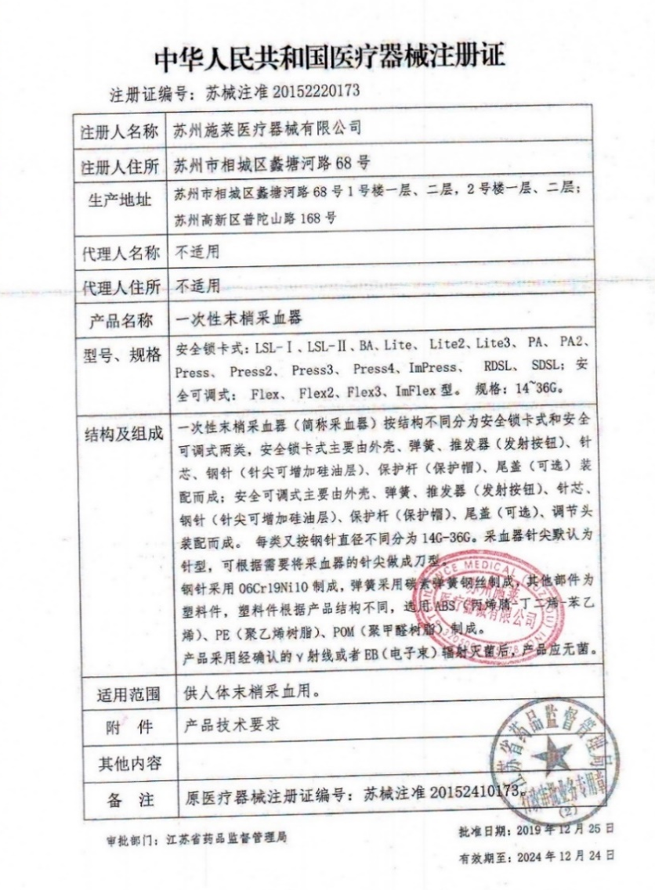

Medical Device Registration Certificate of the People's Republic of China
Registration Certificate No. | SXZZ No.20152220173
Applicant | Suzhou SteriLance Medical Equipment Co., Ltd.
Applicant Home Address | 68 litanghe Road, Xiangcheng District, Suzhou
Manufacturing Site | No. 68, litanghe Road, Xiangcheng District, Suzhou City, 1st and 2nd floors, 1st and 2nd floors, building 1; No. 168, Putuoshan Road, high tech Zone, Suzhou
Product Name | Disposable peripheral blood collector
Device Classification | Class II
Model &Specification | Safety lock card type：LSL-Ⅰ、LSL-Ⅱ、BA、Lite、 Lite2、Lite3、 PA、 PA2、 Press、 Press2、 Press3、 Press4、ImPress、 RDSL、 SDSL；safety adjustable type： Flex、 Flex2、Flex3、ImFlex。Specification: 14~36G。
Structure and Components | The disposable peripheral blood collector (referred to as blood collector) can be divided into two types according to its structure: safety lock type and safety adjustable type. The safety lock type is mainly composed of shell, spring, pusher (launch button), needle core, steel needle (silicon oil layer can be added to the needle tip), protection rod (protection cap) and tail cover (optional). The safety adjustable type is mainly composed of shell, spring, pusher (launch) Button), needle core, steel needle (silicon oil layer can be added to the needle tip), protective rod (protective cap), tail cover (optional) and adjusting head are assembled. Each type is divided into 14g-36g according to the different diameter of steel needle. The needle tip of the blood collector is the needle type by default. The needle tip of the blood collector can be made into the knife type according to the needs. Steel needle is made of 06Cr19Ni10, spring is made of carbon spring steel wire, other parts are plastic parts, plastic parts are made of ABS (acrylonitrile butadiene styrene), PE (polyethylene resin) and POM (polyformaldehyde resin) according to different product structure. After the product is sterilized by confirmed γ - ray or EB Radiation, the product shall be sterile.
Intended Use | For blood collection at the ends of human body.
Attachment | Requirements of Products Technology
Other Contents | NA
Remarks | Previous Registration Certificate No: SXZZ 20152410173。
Approval department | Jiangsu Provincial Medical Products Administration
Approval date | 2019-12-25
Valid until | 2024-12-24

